Chestnuts Curriculum overview – Autumn Term 2026
Autumn Term 1
Theme: Traditional Tales.
Books we will be focusing on:
Week 1 & 2: The Ghanaian Goldilocks
Week 3 & 4: The Three Billy Goats Gruff
Week 5 & 6: Little Red Riding Hood
Week 7 & 8: Rapunzel

Autumn Term 2
Theme: Traditional Tales.
Books we will be focusing on:
Week 1 & 2: The Princess and the Pea
Week 3 & 4: Jack and the Beanstalk
Week 5 & 6: Chicken Licken
Week 7: The Gingerbread Man


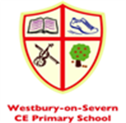

Focus Nursery Rhymes – Autumn 1 | Focus Nursery Rhymes – Autumn 2
Twinkle, Twinkle Little Star | Old MacDonald had a Farm
The wheels On the Bus | Head, Shoulders, Knees and Toes
Incy, Wincy Spider | Row, Row, Row your Boat
Baa, Baa, Black Sheep | Humpty Dumpty

Focus Sound of the week – Autumn 2
Week 1 - S | Week 6 - N
Week 2 - A | Week 7 – Recap SATPIN
Week 3 - T
Week 4 - P
Week 5 - I
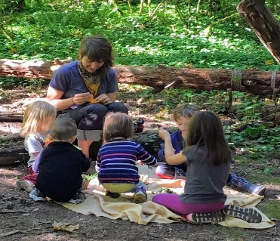

8.30-10.15 | 10.15-11.45 | 11.45-12.00 | 12.00-1.00 | 1.00-2.45 | 2.45-3.00
Arrive, register and Phonics activities and child led play in EYFS area/classroom | Snack then Math’s activities and child led play in playground/ EYFS area and tidy up time. | Storytime and singing. Getting ready for lunch. 11.30 -12 PE - Mondays | Lunch in hall, and child led play in room/outside area | Forest school (Wednesdays with Willow Class), child led play in EYFS area/classroom. | Story, singing and getting ready for home.

