**Chestnuts Curriculum overview – Autumn Term 2025**

**Autumn Term 2**

**Theme: Traditional Tales.**

Books we will be focusing on:

Week 1 & 2: The Ghanaian Goldilocks

Week 3 & 4: Little Red Riding Hood

Week 5 & 6: The Gingerbread Man

Week 7: Princess and the Pea

**Autumn Term 1**

**Theme: Traditional Tales.**

Books we will be focusing on:

Week 1 & 2: Rapunzel

Week 3 & 4: Chicken Licken

Week 5 & 6: Pinocchio

Week 7 & 8: Cinderella

|  |  |
| --- | --- |
| **Focus Nursery Rhymes – Autumn 1** | **Focus Nursery Rhymes – Autumn 2** |
| Twinkle, Twinkle Little Star | Old MacDonald had a Farm |
| The wheels On the Bus | Head, Shoulders, Knees and Toes |
| Incy, Wincy Spider | Row, Row, Row your Boat |
| Baa, Baa, Black Sheep | Humpty Dumpty |

|  |  |
| --- | --- |
| **Focus Sound of the week – Autumn 2** |  |
| Week 1 - S | Week 6 - N |
| Week 2 - A | Week 7 – Recap SATPIN |
| Week 3 - T |  |
| Week 4 - P |  |
| Week 5 - I |  |

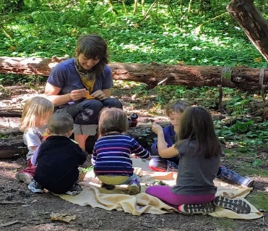

|  |  |  |  |  |  |
| --- | --- | --- | --- | --- | --- |
| 8.30-10.15 | 10.15-11.45 | 11.45-12.00 | 12.00-1.00 | 1.00-2.45 | 2.45-3.00 |
| Arrive, register, Phonics activities and child led play in EYFS area/classroom | Snack, Math’s activities and child led play in playground/ EYFS area and tidy up time. | Story time and singing. Getting ready for lunch. | Lunch in hall and then back to our room for child led play | Forest school (Wednesdays with Willow Class), child led play in EYFS area/classroom. | Story, singing and getting ready for home. |

