Chestnuts Curriculum overview – Spring Term 2026
Spring Term 2
Theme: Hairy Maclary.
Books we will be focusing on:
Week 1 & 2: Hairy Maclary Caterwaul Caper
Week 3 & 4: Hairy Maclary Rumpus at the vets
Week 5 & 6: Hairy Maclary Showbusiness

Spring Term 1
Theme: Hairy Maclary.
Books we will be focusing on:
Week 1 & 2: Hairy Maclary from Donaldson Dairy
Week 3 & 4: Hairy Maclary Bone
Week 5 & 6: Hairy Maclary Slinky Malinki


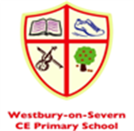

Focus Nursery Rhymes – Spring 1 | Focus Nursery Rhymes – Spring 2
Hickory Dickory Dock | Ten Fat Sausages
Dingle Dangle Scarecrow | One, two buckle my shoe
Five Little Speckled Frogs | Hey Diddle Diddle
One finger, One Thumb keep moving | Here we go round the mulberry bush

Focus Sound of the week – Spring 1 | Focus Sound of the week – Spring 2
Week 1 – M | Week 1 – E
Week 2 – D | Week 2 – U
Week 3 – G | Week 3 – R
Week 4 – O | Week 4 – H
Week 5 - C | Week 5 - B

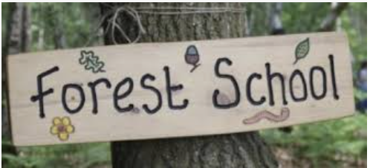

8.30-10.15 | 10.15-11.45 | 11.45-12.00 | 12.00-1.00 | 1.00-2.45 | 2.45-3.00
Arrive, register, Phonics activities and child led play in EYFS area/classroom | Snack, Math’s activities and child led play in playground/ EYFS area and tidy up time. | Story time and singing. Getting ready for lunch. | Lunch in hall and then back to our room for child led play | Forest school (Wednesdays with Willow Class), child led play in EYFS area/classroom. | Story, singing and getting ready for home.

