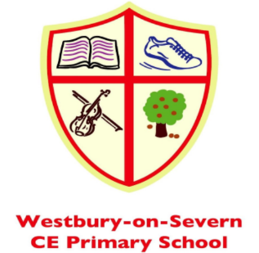

Chestnut Class (Preschool)
Key Information for Parents
2026-2027
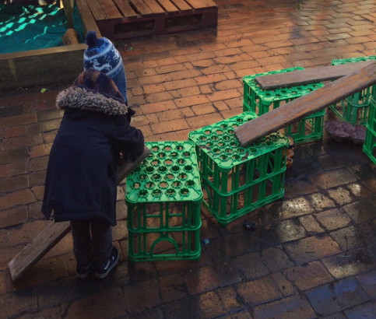
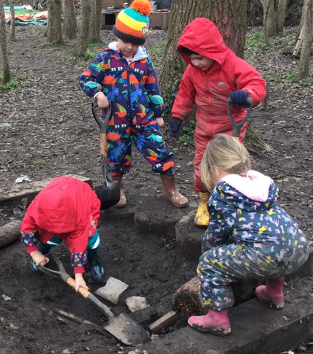
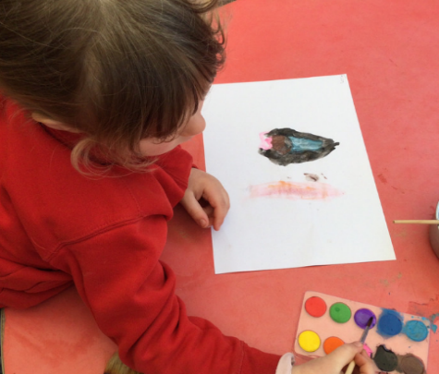
Chestnut class is the Preschool class at Westbury on Severn CE Primary school. We currently accept children the term following their third birthday.
Opening Hours
We follow the same term dates as the main school and are open Monday – Thursday 8.30am – 3pm. If you would like a Friday session, please speak to Mrs Trigg who can advise if and waiting times for these sessions.
Teaching staff
Mrs Trigg teachers every day in Preschool and is supported by the Teaching Assistants in Willow Class. Mrs Trigg has planning time on Friday Mornings. Mrs Trigg has Level 3 Early Years Qualifications, Level 3 Forest School Leader and Paediatric First aid, plus years of experience.
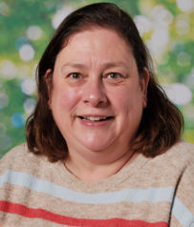
Mrs Jo Trigg
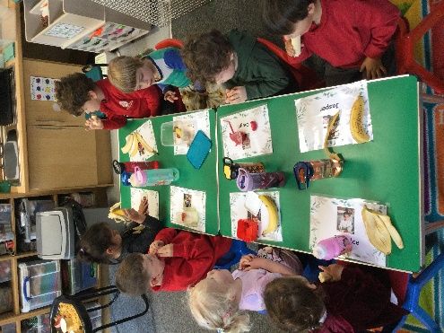
Preschool has their own classroom and each child has a personal locker. We share the outdoor area with Willow class (YR and Y1) which leads straight off our classroom and has a wide range of enticing play activities for pupils to play with every day, whatever the weather. In September 2025, we relocated to a larger classroom to accommodate more pupils, still with access to the shared outside area.

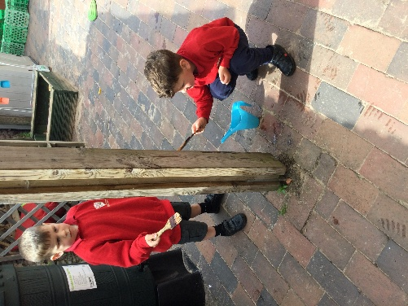
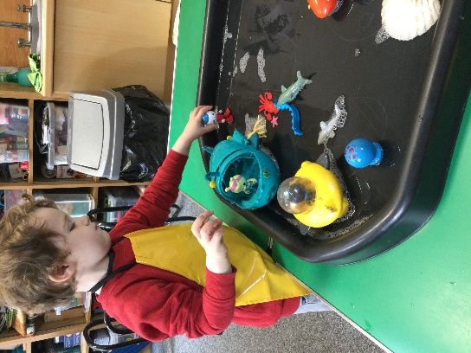
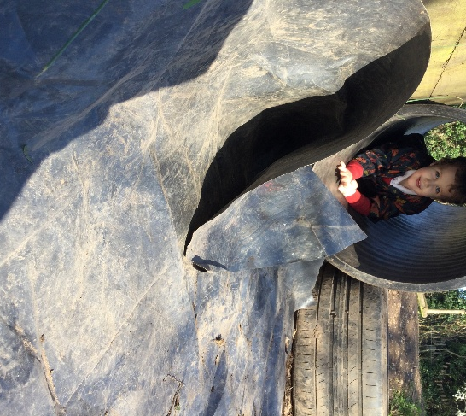
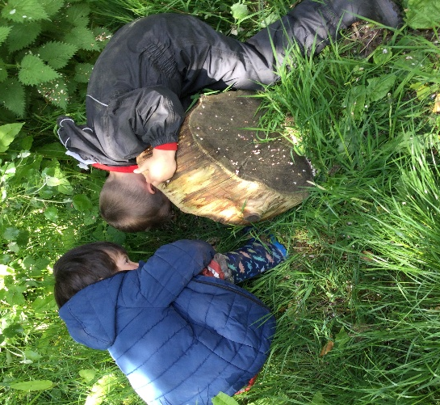
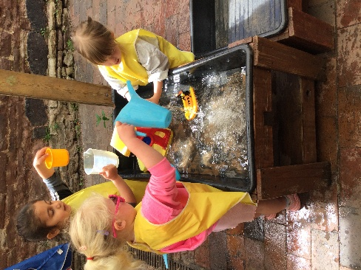
Uniform and clothes
We want children to be comfortable at Preschool and wear clothes that they feel happy in. To acknowledge that they are part of our school we ask that children wear either a red school sweatshirt or cardigan, either with the school logo or just plain. Children can then choose to either wear other items of the school uniform or their home clothes to Preschool. We ask that all clothes have your child’s name in them. We also ask that children bring a daily change of clothes packed into their bag in case of toileting accidents, mud, or any other spillages.
Snacks

Little children get hungry often so we ask parents to pack snacks for morning and afternoon in their bags so that they can keep well fuelled throughout the day. Please ensure that these are healthy and no/low sugar. Fresh fruit, rice cakes/crackers, a healthy cereal bar or cheese/yoghurt are some ideas.

Lunch
Parents can order a hot school dinner for their children via the school office a week in advance at a cost of £3.00. This includes pudding, side salad, bread, and extra fruit. Alternatively, pupils can bring in a packed lunch. We ask that they do not have fizzy drinks or sweets for lunch.
Children eat lunch in the hall with the rest of the school. Mrs Trigg sits at their table with them, supporting them with packaging or cutting up food, encouraging table manners and teaching them how to use cutlery, if they are eating a hot school dinner.




Toileting
We ask that pupils are toilet trained before they start in Preschool. However, we understand that sometimes toilet training may not be completed and your child either has frequent accidents or may even need to wear a nappy or pull up in our setting. If this is the case, we ask that parents supply us with sufficient changes of clothes, wipes, spare pants, and/or nappies/pull ups daily. These can be brought into school in a separate bag daily with your child. Please discuss this matter with Mrs Trigg before your child starts Preschool, especially if your child has special/medical needs.
Costs:
We accept both 15hrs and 30hrs funding. Please visit the link below to set up an account to access your code which is needed to validate your hours.
https://www.gov.uk/apply-free-childcare-if-youre-working
We also accept Childcare tax-free vouchers. Please visit the link below to set up an account
https://www.gov.uk/tax-free-childcare
All other hours attend by your child will be charged at a rate of £6.50 per hour, which you will be invoiced for each term.
Some families split the funding between two different settings, which is possible, so please talk to Mrs Trigg. To get the most out of their time in Chestnuts, we ask that you book a minimum of two sessions with us. This helps children build friendships and supports with school readiness. However, we can negotiate hours that suit you and your child best and children often build to longer hours.
Curriculum
We have planned a curriculum that prepares pupils for their Reception year and streamlines their learning with the main school approaches (for example in phonics and maths). We focus on a quality text across two weeks and plan the children’s learning around this. Children have lots of opportunities for outdoor play, free flow from the class to the outside area, joining Willow class in their play at times, plus singing and learning nursery rhymes daily.
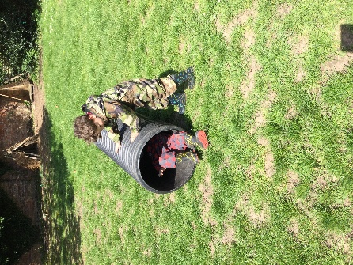
8.30-10.15 | 10.15-11.45 | 11.45-12.00 | 12.00-1.00 | 1pm -2.45 | 2.45 -3.00
Arrive, register, Maths activities and child led play in EYFS area/classroom | Snack, Phonics activities and child led play in playground/ EYFS area and tidy up time. | Story time and singing. Getting ready for lunch. | Lunch in hall and then back to our room for child led play | Forest school and/or Trim trail  Every afternoon | Singing, story time and getting ready to go home.
A Typical day

Early Phonics
We follow the “Little Wandle” programme, which is the programme Reception and Year 1 follow once they join school. We prepare the children for learning phonics more formally in their Reception year by focusing on listening skills, turn taking, oral blending and letter recognition. Children have a daily activity led by the teacher, which helps them identify things like syllables, alliteration and rhyme.
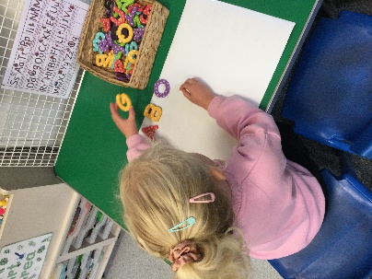
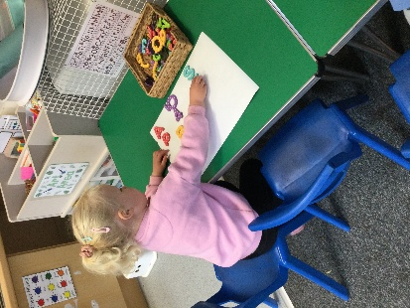

Early Maths
We follow a Mastery approach, in line with the rest of the school, and have planned the curriculum across the entire year to ensure the children develop their mathematical knowledge to start Reception with the number sense they need. The children learn through a variety of activities, including play. These activities could be singing nursery rhymes, counting activities connected to Number Blocks/ Numicon, craft, and pattern formation.
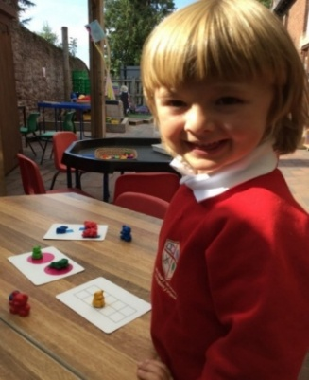
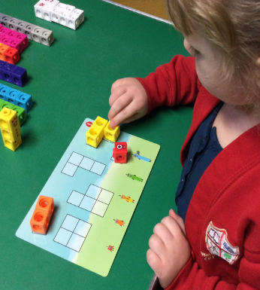
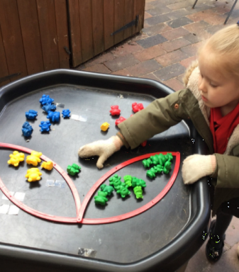

Special Educational Needs
We are a highly inclusive school and our SENCO works closely with all the classes- Chestnuts is not exception. If your child has special educational needs or a disability, we will ensure that the curriculum and resources are adapted to meet their needs. If you have concerns about your child’s progress, you can request that our SENCO observes your child. If need be, we can contact outside agencies to support them. Please refer to our SEND policy on our website, or speak, in the first instance, to Mrs Trigg if you would like some more information about how we can support your child.

Tapestry


When your child enrols with us at Chestnuts, we will give you a login to our online Learning Journal. The teachers across both Chestnuts and Willow Classes take photos of your child playing and learning and send these home regularly to update you on their progress and to reassure you that they are having an enjoyable time at our setting. You can download the free app to your phone and also comment and interact with photos. More than one parent can sign up too. We find it is a lovely way to communicate with you about all the enriching and fun activities the children are participating in every day since we understand that often children are too tired at the end of the day to remember everything.

Early Years Pupil Premium
Your child’s early years’ education provider could get up to £388 per year to help with your child’s education. This will be paid direct to your provider.

Who can apply
You can apply for early years’ pupil premium if:
- your child is aged 9 months to 2 years
- your child is 3 or 4 and you get 15 hours free childcare
You must also get at least one of the following:
- Income Support
- income-based Jobseeker’s Allowance
- income-related Employment and Support Allowance
- support under part six of the Immigration and Asylum Act 1999
- the guaranteed element of State Pension Credit
- Child Tax Credit (provided you are not also entitled to Working Tax Credit) and have an annual gross income of no more than £16,190
- Working Tax Credit run-on, which is paid for 4 weeks after you stop qualifying
- Universal Credit - your household income must be less than £7,400 a year after tax not including any benefits you get
You may also get early years’ pupil premium if your child is currently being looked after by a local authority in England or Wales or if your child has left care in England or Wales through:
- adoption
- special guardianship order
- a child arrangements order


Please follow us on Instagram.

We hope this information gives you a flavour of what we offer your child in our Chestnuts class.

If you would like to arrange a visit please phone 01452 760303 or email admin@westbury-on-severncofe.gloucs.sch.uk to make arrangements.

